LAB2 PROGRAMS
1)

#include <stdio.h>

struct Process {
int pid;
int arrival;
int burst;
int completion;
int turnaround;
int waiting;
};

int main() {
int n, i, j;
float avg_waiting = 0, avg_turnaround = 0;

printf("Enter number of processes: ");
scanf("%d", &n);

struct Process proc[n];

printf("Enter ProcessID, ArrivalTime, BurstTime for %d processes:\n", n);
for(i = 0; i < n; i++) {
printf("Process %d: ", i+1);
scanf("%d %d %d", &proc[i].pid, &proc[i].arrival, &proc[i].burst);
}

for(i = 0; i < n-1; i++) {
for(j = 0; j < n-i-1; j++) {
if(proc[j].arrival > proc[j+1].arrival) {
struct Process temp = proc[j];
proc[j] = proc[j+1];
proc[j+1] = temp;
}
}
}

int current_time = 0;

for(i = 0; i < n; i++) {
if(current_time < proc[i].arrival) {
current_time = proc[i].arrival;
}

proc[i].completion = current_time + proc[i].burst;
proc[i].turnaround = proc[i].completion - proc[i].arrival;
proc[i].waiting = proc[i].turnaround - proc[i].burst;
current_time = proc[i].completion;

avg_waiting += proc[i].waiting;
avg_turnaround += proc[i].turnaround;
}

printf("\nProcess Scheduling - FCFS Algorithm\n");
printf("====================================\n");
printf("PID\tArrival\tBurst\tCompletion\tTurnaround\tWaiting\n");
printf("----------------------------------------------------------\n");
for(i = 0; i < n; i++) {
printf("%d\t%d\t%d\t%d\t\t%d\t\t%d\n",
proc[i].pid, proc[i].arrival, proc[i].burst,
proc[i].completion, proc[i].turnaround, proc[i].waiting);
}

printf("\nAverage Waiting Time: %.2f\n", avg_waiting/n);
printf("Average Turnaround Time: %.2f\n", avg_turnaround/n);

return 0;
}
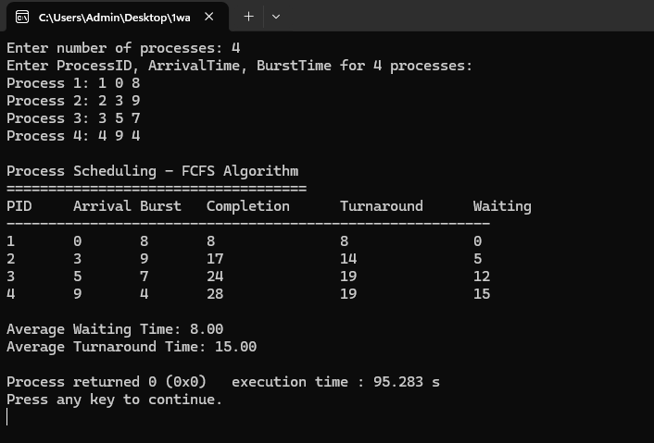

2)
#include <stdio.h>

int main() {
int n, i;
int pid[10], arrival[10], burst[10], ct[10], tat[10], wt[10];
int done[10] = {0};
float avg_wt = 0, avg_tat = 0;

printf("Enter number of processes: ");
scanf("%d", &n);

for(i = 0; i < n; i++) {
printf("P%d: PID AT BT = ", i+1);
scanf("%d%d%d", &pid[i], &arrival[i], &burst[i]);
}

int time = 0;
while(1) {
int min = 999, pos = -1;

for(i = 0; i < n; i++) {
if(!done[i] && arrival[i] <= time && burst[i] < min) {
min = burst[i];
pos = i;
}
}

if(pos == -1) {
time++;
int all_done = 1;
for(i = 0; i < n; i++) if(!done[i]) all_done = 0;
if(all_done) break;
} else {
ct[pos] = time + burst[pos];
tat[pos] = ct[pos] - arrival[pos];
wt[pos] = tat[pos] - burst[pos];
done[pos] = 1;
time = ct[pos];
}
}

printf("\nPID AT BT CT TAT WT\n");
for(i = 0; i < n; i++) {
printf("%d %d %d %d %d %d\n", pid[i], arrival[i], burst[i], ct[i], tat[i], wt[i]);
avg_wt += wt[i];
avg_tat += tat[i];
}

printf("\nAvg WT: %.2f\n", avg_wt/n);
printf("Avg TAT: %.2f\n", avg_tat/n);

return 0;
}

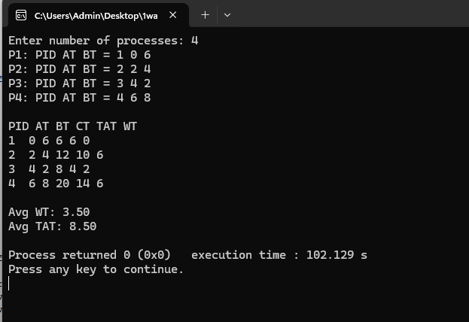
3)
#include <stdio.h>

int main() {
int n, i;
int pid[10], arrival[10], burst[10], remaining[10];
int ct[10], tat[10], wt[10];
int done[10] = {0};
float avg_wt = 0, avg_tat = 0;

printf("Enter number of processes: ");
scanf("%d", &n);

for(i = 0; i < n; i++) {
printf("P%d: PID AT BT = ", i+1);
scanf("%d%d%d", &pid[i], &arrival[i], &burst[i]);
remaining[i] = burst[i];
}

int time = 0;
while(1) {
int all_done = 1;
for(i = 0; i < n; i++) {
if(!done[i]) all_done = 0;
}
if(all_done) break;

int min = 999, pos = -1;
for(i = 0; i < n; i++) {
if(!done[i] && arrival[i] <= time && remaining[i] < min) {
min = remaining[i];
pos = i;
}
}

if(pos == -1) {
time++;
} else {
remaining[pos]--;
time++;
if(remaining[pos] == 0) {
ct[pos] = time;
tat[pos] = ct[pos] - arrival[pos];
wt[pos] = tat[pos] - burst[pos];
done[pos] = 1;
}
}
}

printf("\nPID AT BT CT TAT WT\n");
for(i = 0; i < n; i++) {
printf("%d %d %d %d %d %d\n", pid[i], arrival[i], burst[i], ct[i], tat[i], wt[i]);
avg_wt += wt[i];
avg_tat += tat[i];
}

printf("\nAvg WT: %.2f\n", avg_wt/n);
printf("Avg TAT: %.2f\n", avg_tat/n);

return 0;
}
